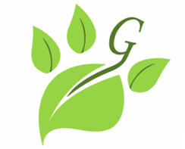
Grangemead Training
Dorothy Walls-Duffin
Tel; 0167 6542 471
Dorothy@grangemeadlabradors.co.uk
www.grangemeadlabradors.co.uk

Training Form
Contact Details
Name (owner): ……………………………………………………………..
Email address: ………………………………………………………………………………………………………………………………………………………………
Telephone Number: ………………………………………………………………………………

Dog Details
Dog Name: …………………………………………………………
Dog Breed: …………………………………………………………
Dog Age: ……………………………………………………………

Here at Grangemead Training we offer many different training options, whether it be you’re interested in gundog training, spaniel training, agility, problematic behaviour or just general obedience… We also offer health and nutrition advice alongside training.
To start with a one-to-one will be held as an assessment, however please tick below which you would prefer to continue with….

One to One Group Sessions

What is it you would like to gain from Grangemead Training?
…………………………………………………………………………………………………………………………………………………………………………………………………………………………………………………………………………………………………………………………………………………………………………………………………………………………………………………………………………………………………………………………………………………………………………………………………………………….

Days that you are available for training…
…………………………………………………………………………………………………………………………………………………………………………………………………………………………………………………………………………………………………………

